Lab 13 Arrays

# Name: Hassan Shahzad

# Class: BSCS 7C

# CMS ID: 211798

## Task 01:

#include <stdio.h>

int main()

{

// declaring array

int array[10] = { -113, -113, -113, -113, -113, -113, -113, -113, -113, -113 };

// printing array

printf("Slot 0 contains a %d\n", array[0]);

printf("Slot 1 contains a %d\n", array[1]);

printf("Slot 2 contains a %d\n", array[2]);

printf("Slot 3 contains a %d\n", array[3]);

printf("Slot 4 contains a %d\n", array[4]);

printf("Slot 5 contains a %d\n", array[5]);

printf("Slot 6 contains a %d\n", array[6]);

printf("Slot 7 contains a %d\n", array[7]);

printf("Slot 8 contains a %d\n", array[8]);

printf("Slot 9 contains a %d\n", array[9]);

return 0;

}

## Output:

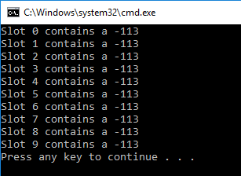

## Task 02:

#include <stdio.h>

int main()

{

// declaring array

int array[10] = { -113, -113, -113, -113, -113, -113, -113, -113, -113, -113 };

for (int i = 0; i < sizeof(array) / sizeof(int); i++)

{

// printing array

printf("Slot %d contains a %d\n", i, array[i]);

}

}

## Output:

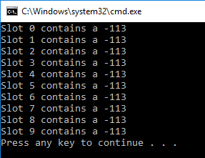

## Task 03:

#include <stdio.h>

int main()

{

int array[10];

for (int i = 0; i < sizeof(array) / sizeof(int); i++)

{

// assigning random values to the array

array[i] = 1 + rand() % 100;

// printing array

printf("Slot %d contains a %d\n", i, array[i]);

}

return 0;

}

## Output:

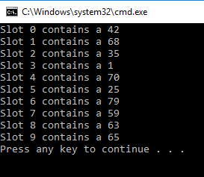

## Task 04:

#include <stdio.h>

int main()

{

// declaring array

int array[1000];

// runs the loop till the last entry

for (int i = 0; i < sizeof(array) / sizeof(int); i++)

{

// assigning random values to array elements

array[i] = 10 + rand() % 90;

// printing array elements

printf("%d ", array[i]);

}

return 0;

}

## Output:

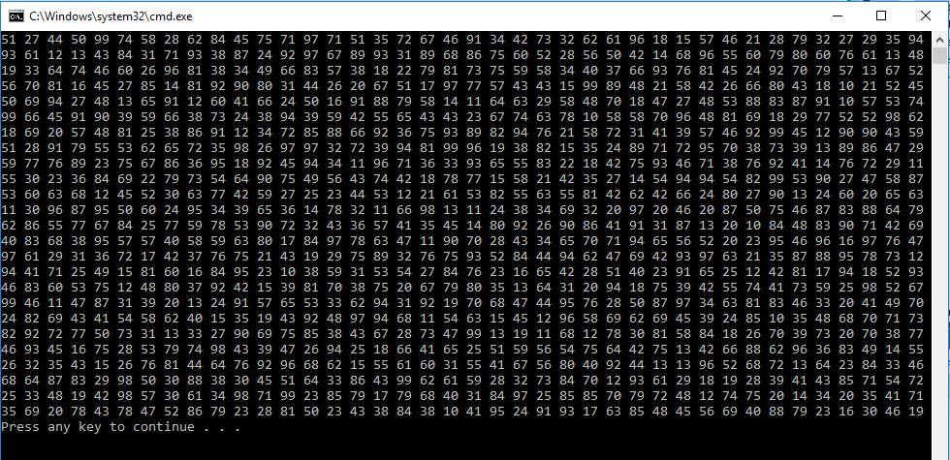

## Task 05:

#include <stdio.h>

int main()

{

int array[10], array2[10]; // declaring arrays

for (int i = 0; i < sizeof(array) / sizeof(int); i++) // runs the loop till last data entry

{

array[i] = 1 + rand() % 100; // assigning random values

array2[i] = array[i]; // assiginig values of array1 to array2

}

printf("Array 1: "); // printing array1

for (int i = 0; i < sizeof(array) / sizeof(int); i++)

{

if (i == 9) // if i = 9 then array[9] is -7

{

printf("%d ", -7);

}

else

printf("%d ", array[i]);

}

printf("\n");

printf("Array 2: "); // printing array 2

for (int i = 0; i < sizeof(array) / sizeof(int); i++)

{

printf("%d ", array2[i]);

}

}

## Output:

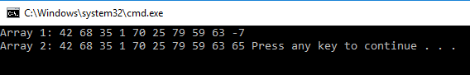

## Task 06:

#define _CRT_SECURE_NO_WARNINGS

#include <stdio.h>

int main()

{

int array[10], a;

for (int i = 0; i < sizeof(array) / sizeof(int); i++)

{

array[i] = 1 + rand() % 50;

printf("%d ", array[i]);

}

printf("\nValue to find: "); // asks the user for value

scanf("%d", &a);

for (int i = 0; i < sizeof(array) / sizeof(int); i++)

{

// searches for the value

if (a == array[i])

printf("%d is in the array\n", a);

}

}

## Output:

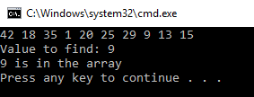

## Task 07:

#define _CRT_SECURE_NO_WARNINGS

#include <stdio.h>

int main()

{

int array[10], a, count = 0; // assigning variables and array

srand(time(NULL));

for (int i = 0; i < sizeof(array) / sizeof(int); i++)

{

// random numbers upto 50

array[i] = 1 + rand() % 50;

printf("%d ", array[i]);

}

printf("\nValue to find: ");

scanf("%d", &a);

for (int i = 0; i < sizeof(array) / sizeof(int); i++)

{

if (a == array[i]){

// value is found then increments the number it appears

count++;

}

}

printf("%d is found in array %d times\n", a, count);

}

## Output:

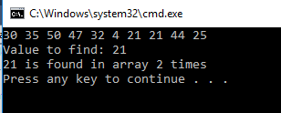

## Task 08:

#define _CRT_SECURE_NO_WARNINGS

#include <stdio.h>

int main()

{

int array[10], a, count = 0;

srand(time(NULL));

for (int i = 0; i < sizeof(array) / sizeof(int); i++)

{

array[i] = 1 + rand() % 50;

printf("%d ", array[i]);

}

printf("\nValue to find: ");

scanf("%d", &a);

for (int i = 0; i < sizeof(array) / sizeof(int); i++)

{

if (a == array[i]){

count++;

}

}

if (count == 0)

{

// if the entered value is not found

printf("%d is not in the array.\n", a);

}

else

printf("%d is found in array %d times\n", a, count);

}

## Output:

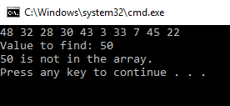

## Task 09:

#define _CRT_SECURE_NO_WARNINGS

#include <stdio.h>

int main()

{

int array[10], a, count = 0;

int location;

srand(time(NULL));

for (int i = 0; i < sizeof(array) / sizeof(int); i++)

{

array[i] = 1 + rand() % 50;

printf("%d ", array[i]);

}

printf("\nValue to find: ");

scanf("%d", &a);

for (int i = 0; i < sizeof(array) / sizeof(int); i++)

{

if (a == array[i]){

location = i;

count++;

}

}

// tells that specific entry is under that slot

printf("%d is present in the array in the slot %d\n", a, location+1);

if (count == 0)

{

// if not present

printf("%d is not in the array.\n", a);

}

// if present

else

printf("%d is in the array %d times\n", a, count);

}

## Output:

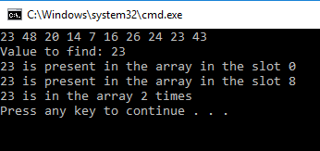

## Task 10:

#define _CRT_SECURE_NO_WARNINGS

#include <stdio.h>

int main()

{

int array[10], a, count = 0, max = -10;

int location;

srand(time(NULL));

for (int i = 0; i < sizeof(array) / sizeof(int); i++)

{

array[i] = 1 + rand() % 50;

printf("%d ", array[i]);

}

printf("\n\n");

for (int i = 0; i < sizeof(array) / sizeof(int); i++)

{

if (array[i] >= max)

{

max = array[i];

}

}

printf("The largest value is: %d\n", max);

return 0;

}

## Output:

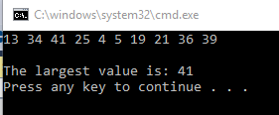

## Task 11:

#define _CRT_SECURE_NO_WARNINGS

#include <stdio.h>

#include <time.h>

int main()

{

int array[10], count = 0, max = -10;

int location;

srand(time(NULL));

for (int i = 0; i < sizeof(array) / sizeof(int); i++)

{

array[i] = 1 + rand() % 50;

printf("%d ", array[i]);

}

printf("\n\n");

for (int i = 0; i < sizeof(array) / sizeof(int); i++)

{

if (array[i] >= max)

{

max = array[i];

location = i;

}

}

printf("The largest value is: %d\n", max);

printf("It is in slot %d\n", location + 1);

return 0;

}

## Output:

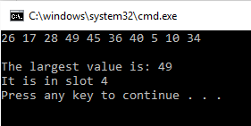

## Task12:

#include <stdio.h>

#include <stdlib.h>

#define MAX_LEN 80

int main()

{

char arr1[][80] = { "alpha", "bravo", "charlie", "delta", "echo" };

int arr2[5] = { 11, 23, 37, 41, 53};

printf( "The first array is filled with the following values:\n\t" );

for ( int i = 0; i < sizeof(arr1)/MAX_LEN; i++ ) // sizeof(arr1) returns 240 bytes

printf( "%s ", arr1[i] );

printf( "\n" );

printf("The second array is filled with the following values: \n");

for (int j = 0; j < sizeof(arr2)/sizeof(int); j++)

printf("%d ", arr2[j]);

printf("\n");

return EXIT_SUCCESS;

}

## Output:

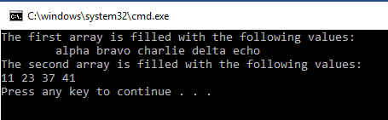

## Task 13:

#define _CRT_SECURE_NO_WARNINGS

#include <stdio.h>

#include <stdlib.h>

void main()

{

int a, location;

char name[][50] = { "Hamza", "Muaz", "Abdul", "lisa", "Azqa" };

double marks[5] = { 99.5, 78.5, 95.6, 96.8, 82.7 };

int id[5] = { 123456, 813225, 823669, 307760, 827131 };

printf("Values: \n");

printf("%s %.1lf %d\n", name[0], marks[0], id[0]);

printf("%s %.1lf %d\n", name[1], marks[1], id[1]);

printf("%s %.1lf %d\n", name[2], marks[2], id[2]);

printf("%s %.1lf %d\n", name[3], marks[3], id[3]);

printf("%s %.1lf %d\n", name[4], marks[4], id[4]);

printf("\n\n");

printf("ID Number to find: ");

scanf("%d", &a);

printf("\n\n");

for (int i = 0; i < sizeof(id) / sizeof(int); i++)

{

if (a == id[i])

{

location = i;

printf("Found in Slot %d\n", location + 1);

printf("Name: %s\n", name[i]);

printf("Average: %.1lf\n", marks[i]);

printf("ID: %d\n", id[i]);

}

}

}

## Output:



